School of Mathematics and Statistics Newsletter

November 2024

# Congratulations to ...

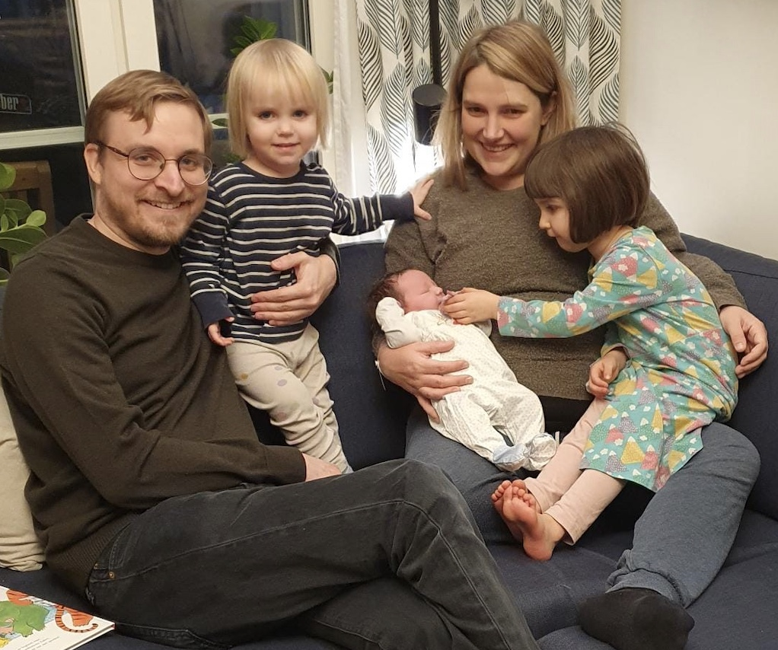• recently-graduated PhD student Fanny Empacher on the birth of Hilda on 7th November. Fanny says “We’re doing well and looking forward to life as a family of five!”

• Ho-Hin Leung on successfully defending his thesis entitled ‘Unveiling the evolutionary history of local poststarburst galaxies through careful Bayesian modelling of their spectra’ on 8th November. Although in the School of Physics and Astronomy, Ho-Hin was jointly supervised by our Michail Papathomas along with Vivienne Wild from Astrophysics. *Hilda and family*

# Farewell to ...

• Solar and Magnetospheric Theory Group PostDoc Jordi De Jonghe, who returned to Belgium at the end of October to start his three-year FWO (Fonds Wetenschappelijk Onderzoe) Junior Postdoctoral Fellowship at KU Leuven.

# Visitors

• In the middle of October Masayuki Henmi (Institute of Statistical Mathematics, Tokyo) and Hiroshi Matzusoe (Nagoya Institute of Technology) visited Peter Jupp for two weeks. They continued work on a long-running project on the role of differential geometry in statistical inference.

# Conferences, Talks and Visits

• On 29th October, Rosemary Bailey and Peter Cameron spoke (remotely) on ‘Permutation groups, lattices and orthogonal block structures’ in the *Ural Workshop on Group Theory and Combinatorics*. According to the organiser Natalia Maslova, it was the first time the workshop had had a double act.

• On 31st October, Peter Cameron gave a remote talk in the *Rutgers University Experimental Mathematics Seminar*, run by Doron Zeilberger, on ‘Finding the jewel in the lotus’. In the audience was former St Andrews undergraduate Caleb Fong.

• Nik Ruskuc has just started a research trip to Australia and New Zealand from 8th November to 16th December where he is visiting James East at the Western Sydney University, to continue their current work on free projection generated regular *-semigroups. Whilst in Australia he expects to attend the Australian Algebra Conference in Canberra and the Joint NZMS/AuMS/AMS meeting in Auckland.

• Colva Roney-Dougal is visiting Colorado State University from 21st October-15th November, to collaborate with Alexander Hulpke and James Wilson on various topics in computational group theory. Whilst there, she gave a talk in the *Rocky Mountain Algebraic Combinatorics* seminar.

• On 14th October Ana De Orellana spoke at the online *Fractal Talks* seminar at Shenzhen Technology University. She also visited the University of Birmingham from 20th-22nd October where she gave a talk titled ‘Orthogonal projections and a continuum of dimensions’.

• Dan Lucas visited the University of Bristol on 24th October to give a talk ‘Stabilising travelling waves from fluid turbulence’ at their *Fluids and Materials* Seminar.

• On 17th October, Fiona Macfarlane visited collaborators at the University of Bath and gave a seminar entitled ‘Discrete and continuum methods to describe invasion processes’ as part of the *Centre for Mathematical Biology* seminar series

• From 21st-25th October, Xiahui Li and Ben Swallow attended a workshop on *Mathematical Models for Twenty-First Century Decisions* at ICMS in Edinburgh, during which they both presented research talks.

# Other News

• Ben Swallow has been appointed *Royal Statistical Society Discussions Papers Editor* by the RSS council and will be taking up the position from January 2025.

• Ian Durbach has been awarded an *ICMS Knowledge Exchange Catalyst* grant. The grant supports collaborations between mathematical scientists and industry, and will fund 11 months of work with the Scottish Avalanche Information Service on forecasting avalanche risk in Scotland, as well as a workshop to be held in mid-2025 on forecasting rare and severe events.

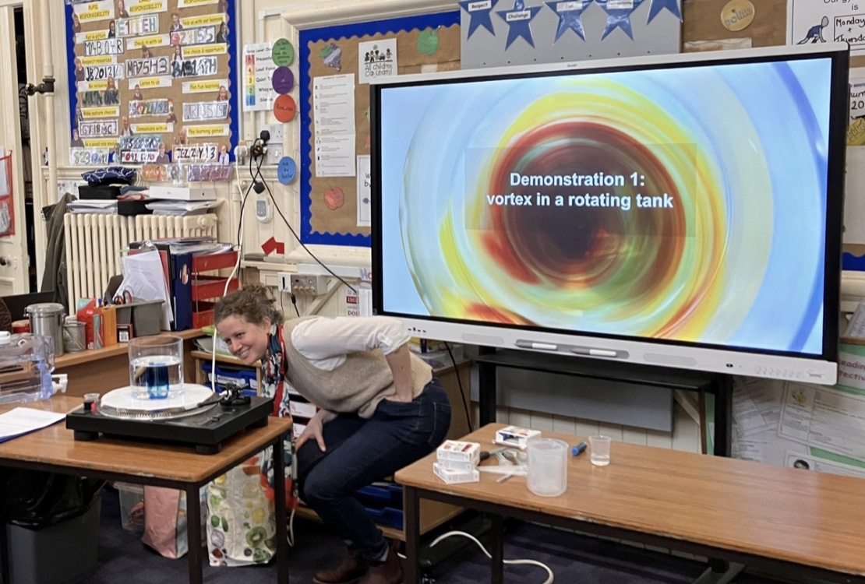• Daphné Lemasquerier and Chris Sutherland did workshops in two P7 classes at the Dunnikier Primary School in Kirkcaldy, as part of a research-inspired music composition project with the Laidlaw music centre at St Andrews. On the 1st November, Daphné and MMath student Hanna Andrejczuk did a workshop on ‘Floating vortices, from the Atlantic Ocean to Jupiter’ with water tanks on record players and kids experimenting with the density of fluids. At the end, half of the pupils had green or blue hands from playing with food colouring, and the rest had sticky hands from corn syrup. On 7th November, Chris did a workshop on statistical ecology around recent research on quantifying the reduction in capercaillie nest predation by pine martens using deer parts as a supplementary food source – ‘Diversionary Feeding’. The lo-tech activity attempted to develop intuition around probability using dice and teams of students were allocated some land (their desks), some fictitious capercaillie nests, and a management action whose success was determined by a die (rolled 100s of times). Each science workshop will be followed by four music workshops led by a composer to compose a new science inspired piece of music with the pupils. The new pieces will be played on the 6th December at the [StAMP](https://stamp.wp.st-andrews.ac.uk/) Christmas Concert at the Laidlaw music centre. *Daphné demonstrates rotating vortices*

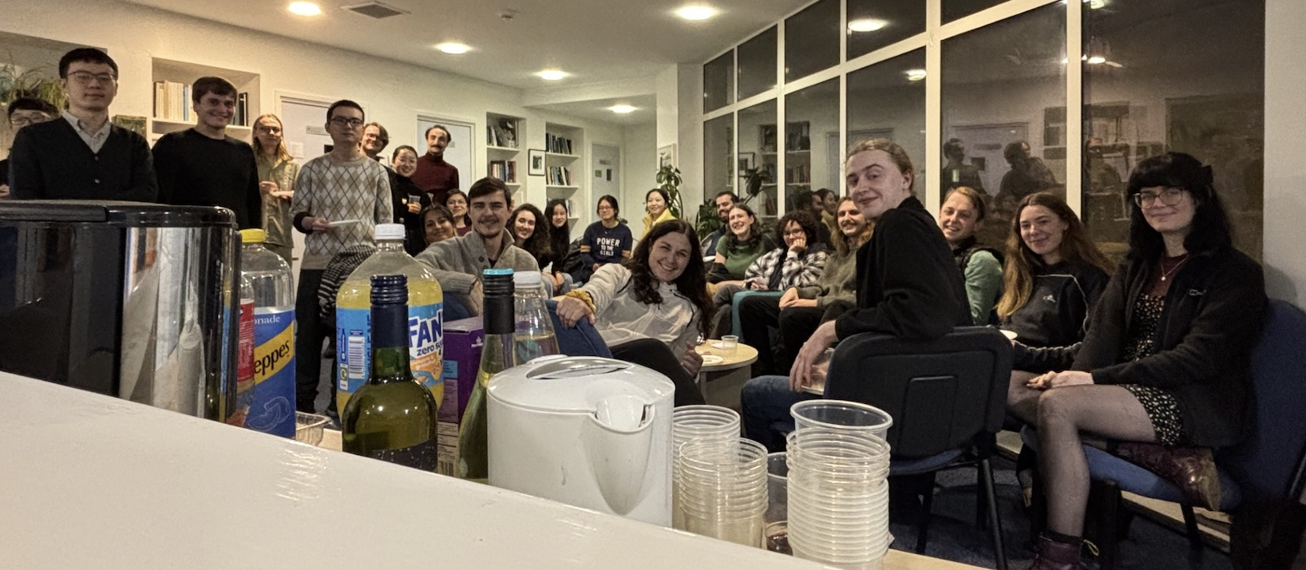

*PhD students social event at the Observatory*

• On 11th November, our Mathematics and Statistics PhD students held a social event at the Observatory. Some 27 students enjoyed an evening of games and (non-research!) conversation.

# Next Issue

• The next edition of the School Newsletter will be circulated in December. Items may be sent to [maths-news@st-andrews.ac.uk](mailto:maths-news@st-andrews.ac.uk?subject=maths-news@st-andrews.ac.uk) at any time but a reminder will be sent out a week before the deadline.